**AIM**

To study and run basic networking commands to gather network configuration details, diagnose network connectivity issues, and understand network behavior and performance.

**THEORY**

**Networking Commands:**

**1. arp -a**

**Purpose**:

ARP is used to resolve IPv4 addresses to physical MAC addresses within a local subnet. The ARP cache stores these mappings to speed up communication.

**Output:**

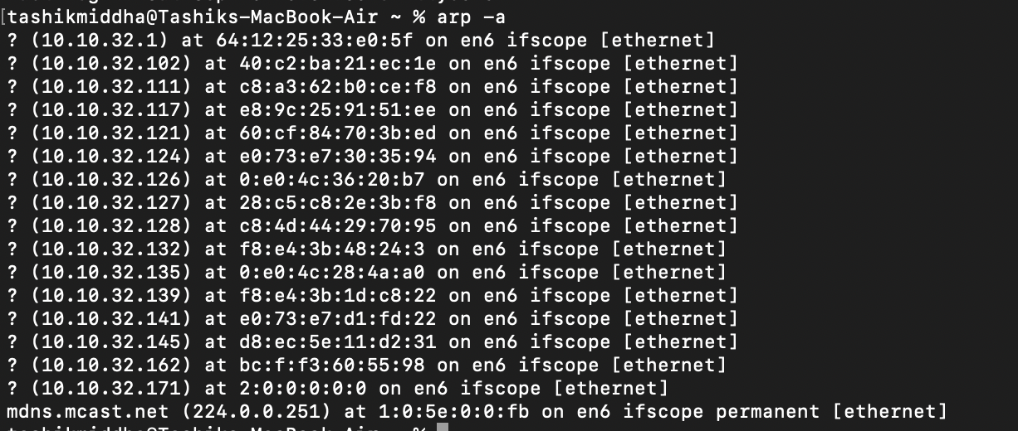

**Use Case**:

Useful for verifying if a device’s MAC address is known and for detecting ARP spoofing attacks.

**2. hostname**

**Explanation**:

The hostname is the identifier assigned to a device on a network, used in DNS and local network identification.

**Output**:



**Use Case**:

Useful for confirming the device’s network identity, especially in multi-device environments.

**3. ifconfig**

**Explanation**:

Shows IPv4 address, subnet mask, and default gateway for each network adapter.

**Output**:

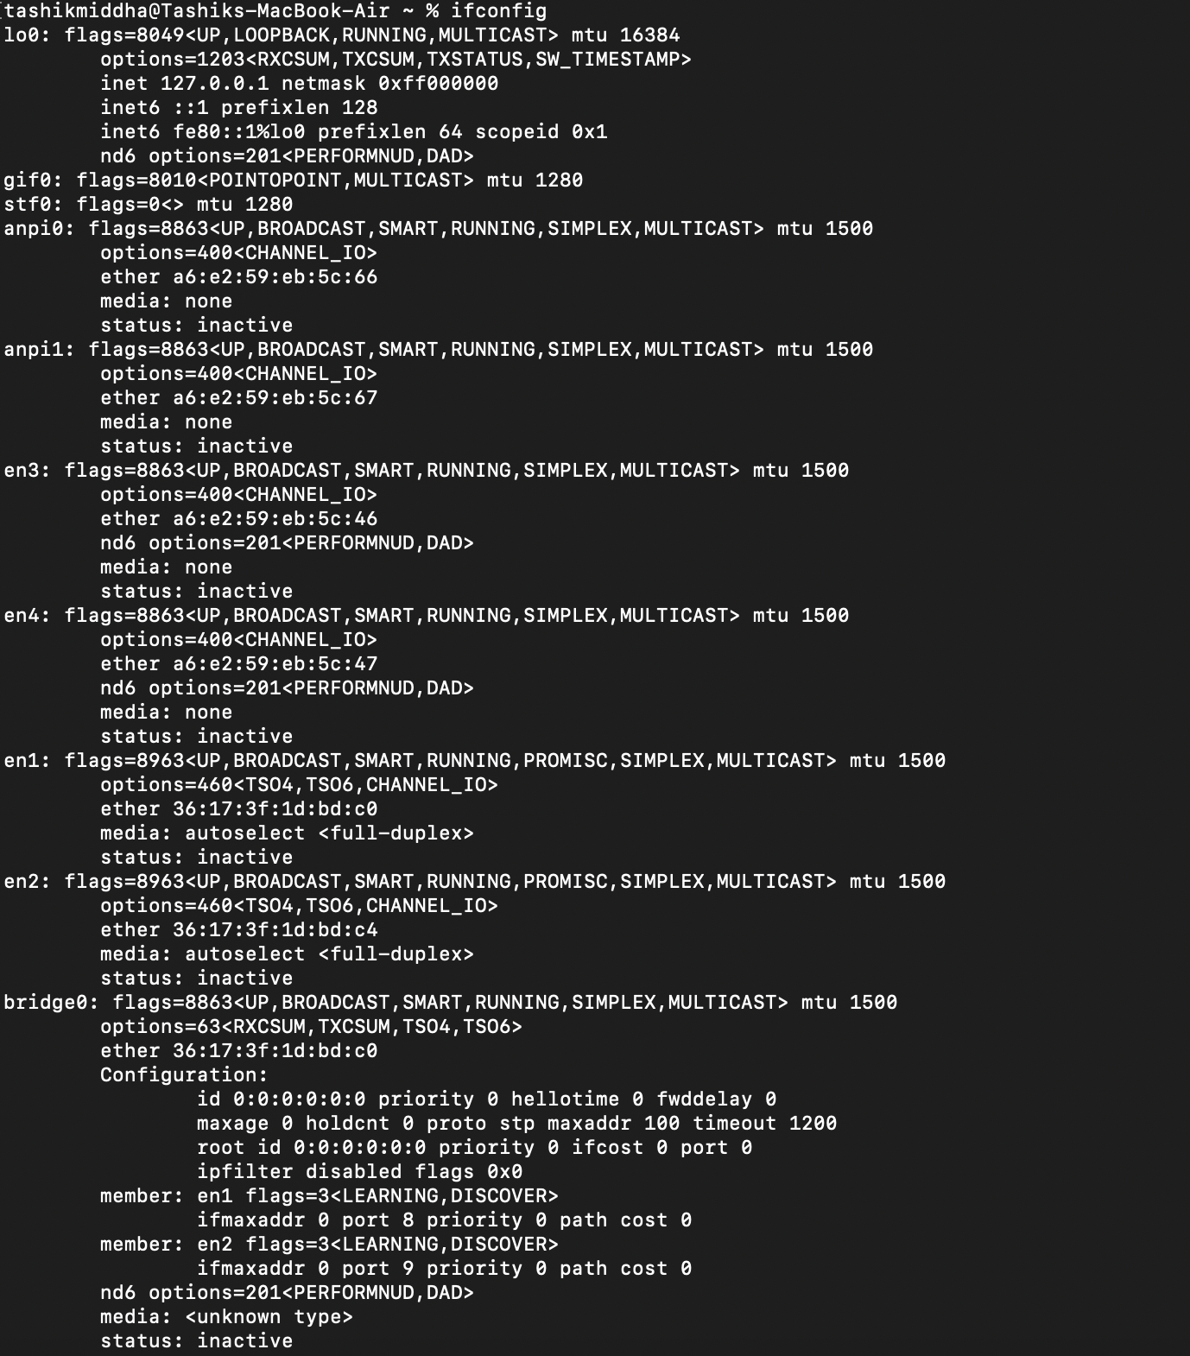

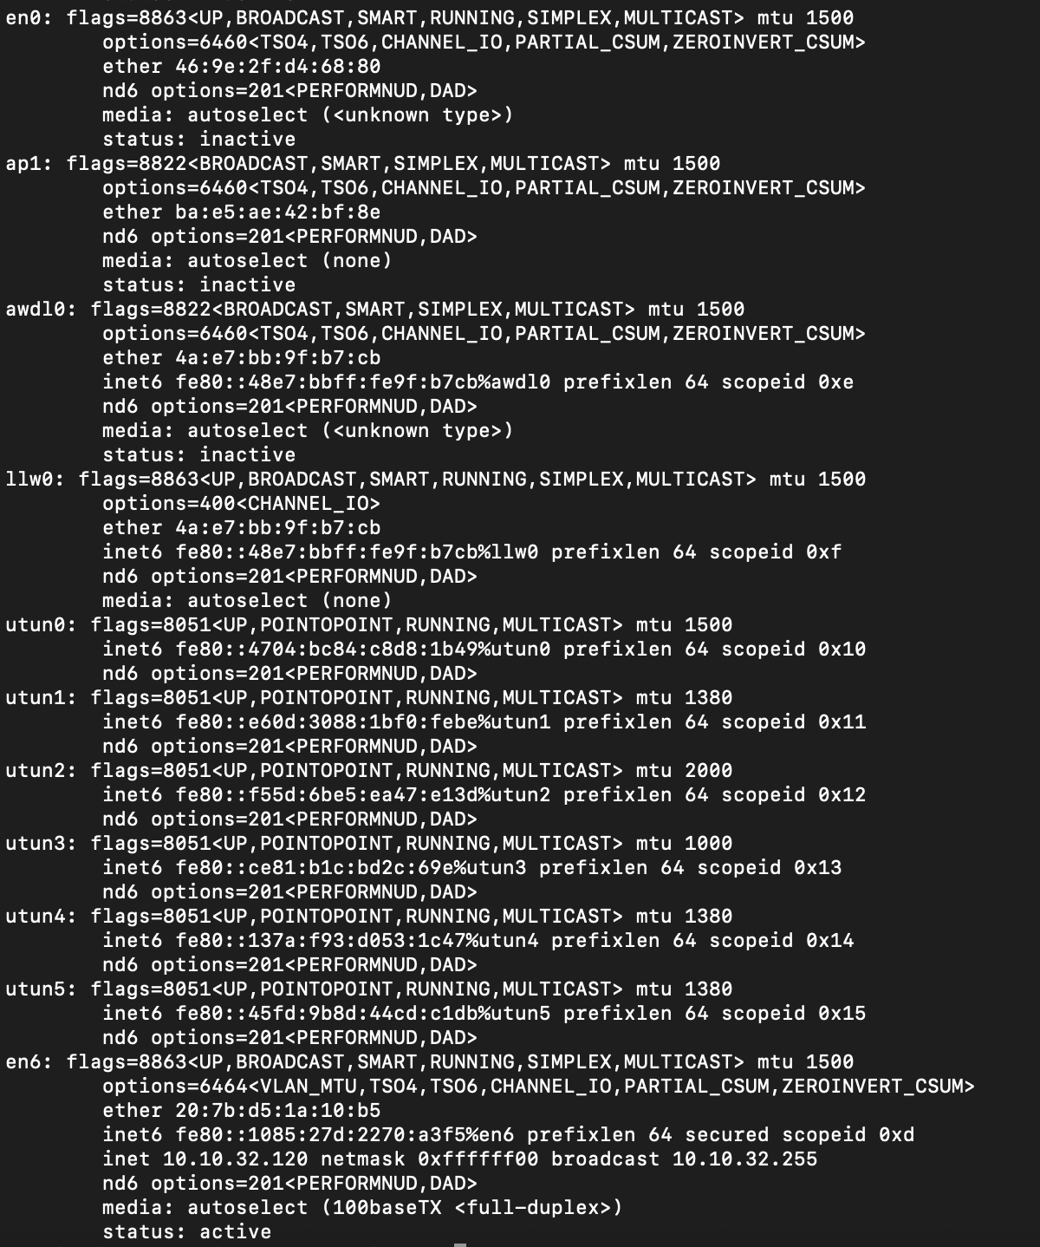

**Use Case**:

Initial step in troubleshooting network connectivity.

**4. ifconfig -a**

**Explanation**:

Includes MAC addresses, DHCP status, DNS servers, lease times, and more.

**Output:**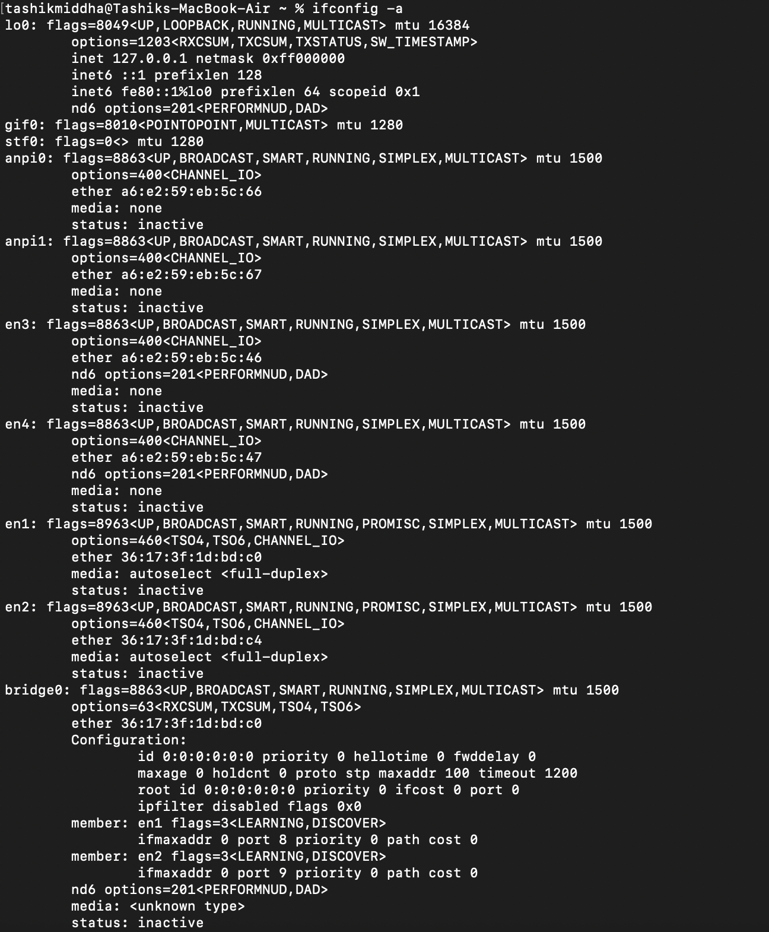

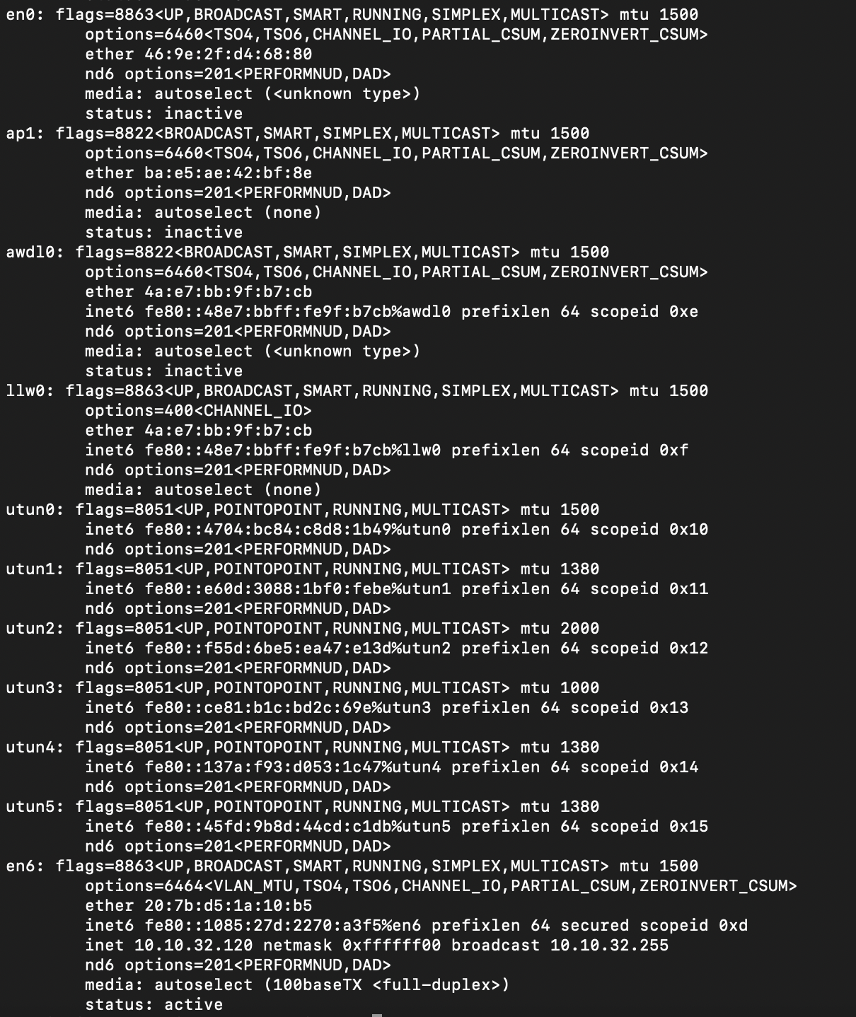

**Use Case**: Useful for in-depth troubleshooting and verifying DHCP and DNS configurations.

**5. ipconfig /renew**

**Explanation**: Forces the client to renew its IP address, useful if the current lease is expired or invalid.

**Output:**

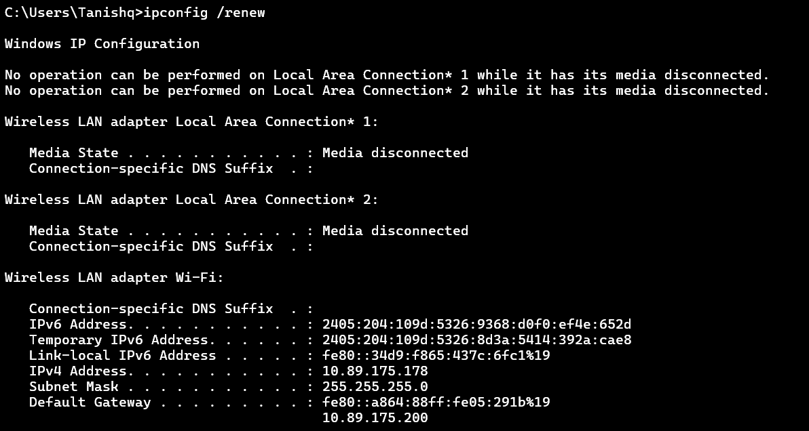

**Use Case**: Resolves IP conflicts or connectivity issues related to DHCP.

**6. ipconfig /release**

**Explanation**:

Drops the current IP address, making the interface temporarily unconfigured.

**Output**:

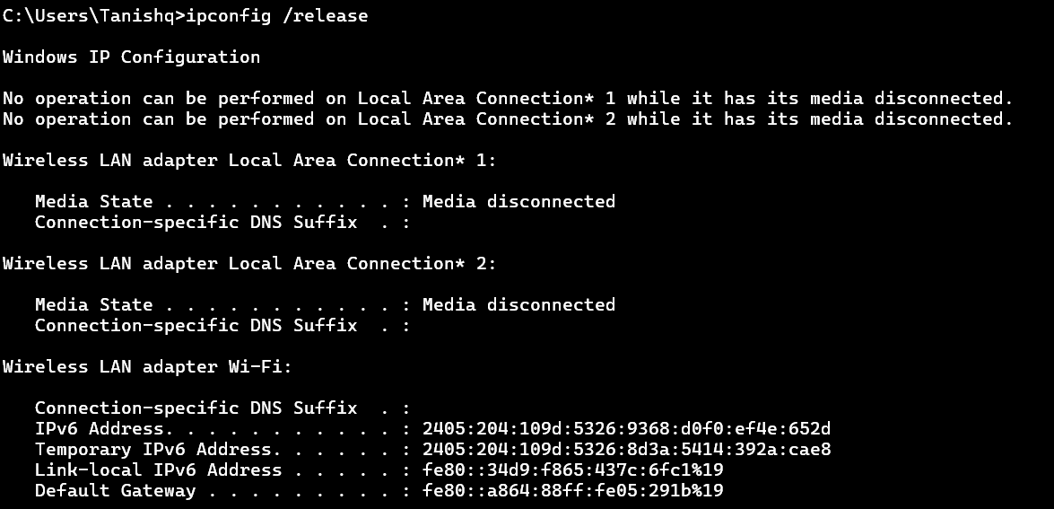

**Use Case**: Used before renewing IP or reconfiguring network settings.

**7. ipconfig /flushdns**

**Explanation**:

Removes all cached DNS entries, forcing the system to query DNS servers anew.

**Output:**

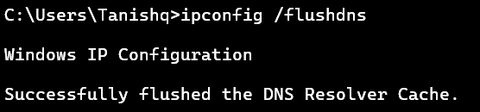

**Use Case**:

Fixes DNS-related issues such as stale or incorrect DNS records.

**8. nbtstat -a <IP address>**

**Explanation**:

NetBIOS is used for name resolution and session services in Windows networks.

**Output**:

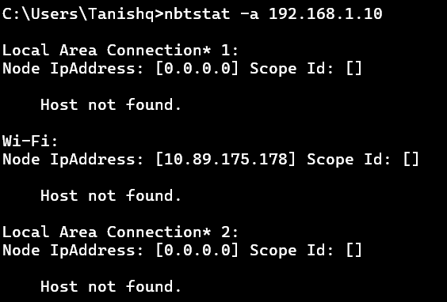

**Use Case**:

Troubleshooting Windows network name resolution and browsing issues.

**9. netdiag – Has been Deprecated in newer versions of windows**

**Explanation**:

Runs a series of tests on network components and reports problems.

**Use Case**:

Comprehensive network troubleshooting tool.

**10. netstat**

**Explanation**:

Shows current network connections and ports in use.

**Output**:

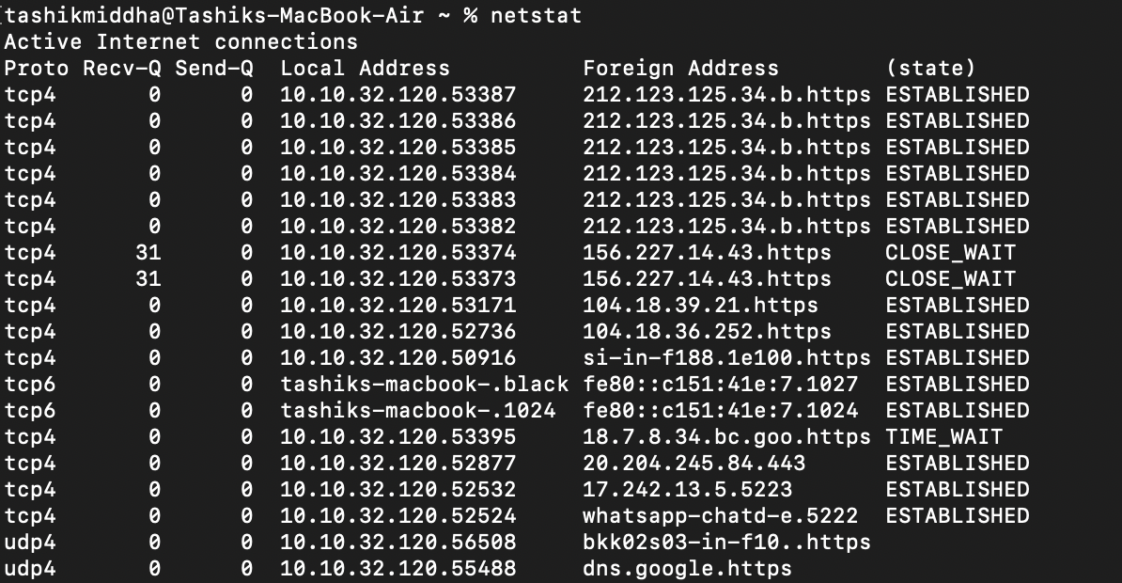

**Use Case**:

Identifying open ports, active connections, and potential unauthorized access.

**11. nslookup <domain>**

**Explanation**:

Interacts with DNS servers to retrieve DNS records.

**Output:**

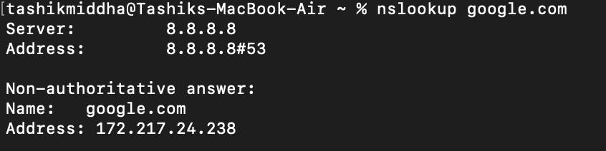

**Use Case**:

Verifying DNS resolution and diagnosing DNS issues.

**12. pathping <IP/hostname>**

* **Purpose**: Combines **ping** and **tracert** to show packet loss and latency at each hop.
* **Usage**: **pathping google.com**
* **Explanation**: Sends packets to each router on the path and calculates statistics.
* **Output Interpretation**: Displays latency and packet loss per hop.
* **Use Case**: Identifying problematic routers or links causing packet loss.

**13. ping <IP/hostname>**

**Explanation**:

Measures round-trip time and packet loss.

**Output:**

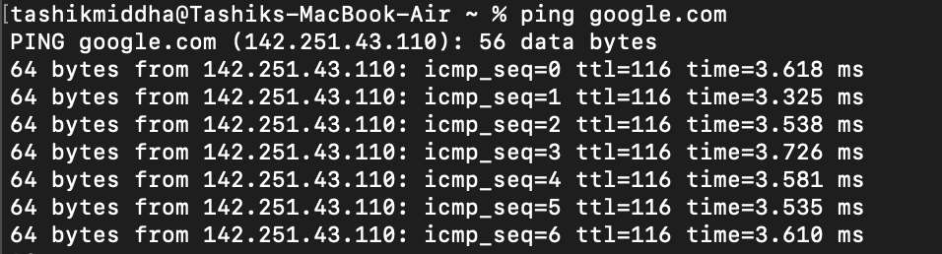

**Use Case**:

Basic connectivity test and latency measurement.

**14. route print**

**Explanation**:

Shows network routes, including destination, gateway, interface, and metric.

**Output:**

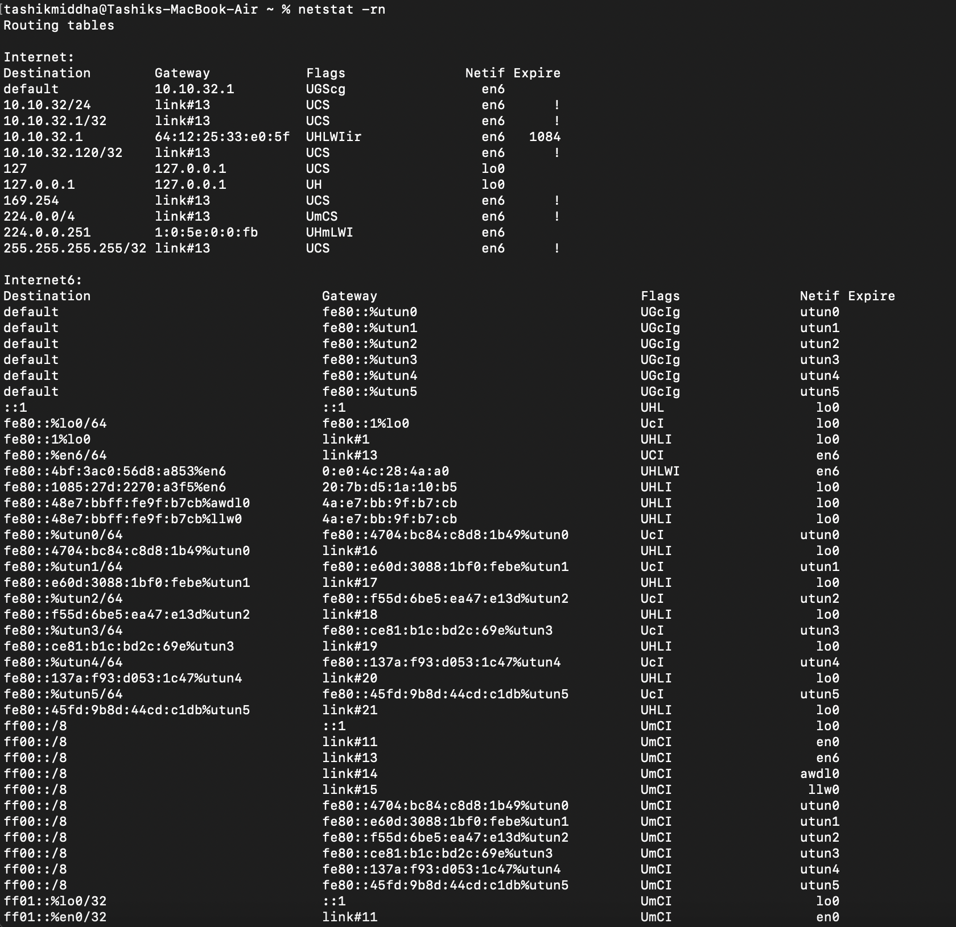

**Use Case**:

Troubleshooting routing issues and verifying static routes.

**15. traceroute <IP/hostname>**

**Explanation**:

Sends ICMP packets with increasing TTL values to identify each hop.

**Output:**

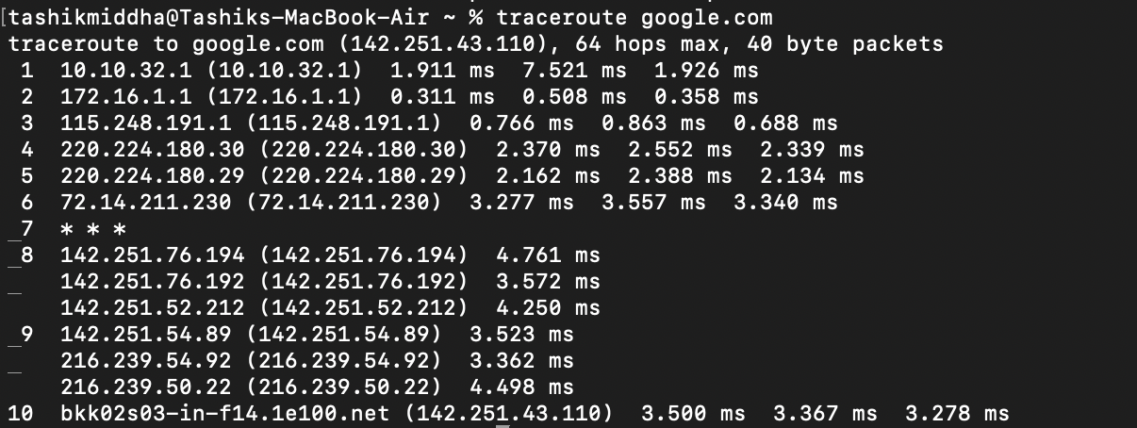

**Use Case**:

Diagnosing routing problems and network delays.

| **Category** | **Commands** | **Purpose** |
| --- | --- | --- |
| IP Configuration | ipconfig, ipconfig /all, ipconfig /renew, ipconfig /release | View and manage IP settings |
| Address Resolution | arp -a, nbtstat -a | Map IP to MAC, NetBIOS name resolution |
| Connectivity Testing | ping, tracert, pathping | Test reachability and route tracing |
| DNS Resolution | nslookup, ipconfig /flushdns | Resolve domain names and manage DNS cache |
| Network Statistics | netstat, route print | View active connections and routing table |
| Diagnostics | netdiag | Comprehensive network diagnostics |
| System Info | hostname | Identify local machine name |

**CONCLUSION:**

Basic networking commands are indispensable tools for network management and troubleshooting. They provide visibility into network configurations, connectivity status, routing paths, and DNS resolution. Proficiency in these commands enables IT professionals to quickly diagnose and resolve network issues, ensuring reliable and secure network operations.